Sum-Meet
Use Case Diagram

Submitted to:

Prof. Ma. Rowena C. Solamo
Faculty Member
Department of Computer Science
College of Engineering
University of the Philippines, Diliman

Submitted by:
Batula, Bryce Spencer
Bayuga, Michael John
Yap, John Theodore

In partial fulfillment of Academic Requirements
for the course
CS 191 Software Engineering I
of the
1st Semester, AY 2015-2016
Unique Reference:
The documents are stored in https://github.com/trackertech568/CS191-Batula-Bayuga-Yap.
[File Reference in GitHub, preferably link.]

Document Purpose:
This document will show the use case model of the application.

Target Audience:
Meeting organizers.

Revision Control

History Revision:
Revision Date | Person Responsible | Version  Number | Modification
09/18/15 | Batula, Bryce  Bayuga, Michael  Yap, John Theodore | 1.0 | Initial Document; Version number should match the one below.

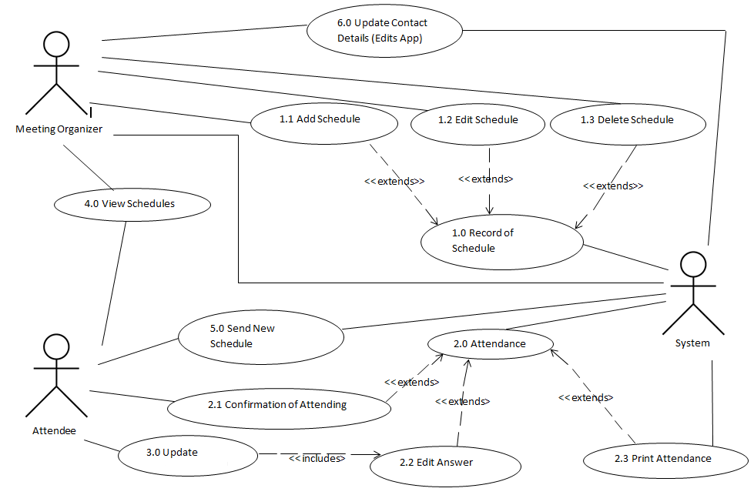

System Name: Meeting and Attendance System

Description: The “Meeting and Attendance System” shows the ‘functions’ for all possible events that can happen when using the application. It is composed of three actors namely, Meeting Organizer, Attendee and the Meeting. It also has twelve use-cases which will interact for every action of the three actors.

Use-Case Diagram:

List of Actors:
Actors | Description
Meeting Organizer | The meeting organizer is the one responsible for meeting schedule. He/she will add new schedule. If there are changes to be made, he/she can also edit it. He/she can delete the schedule if there is a problem on it.
Attendee | The attendee confirms for the attendance. If he/she changes of mind, the answer can be edited. If he/she attends, it will need verification.
System | System is the actor that holds the access to almost everything in the app. If an attendee wants a printed copy of attendance, the meeting will print it for him/her

List of Use-cases:
Use-Case | Description
Use-Case 1.0 Add Meeting | Adds new schedule to the Record of Schedule.  Only the meeting organizer can create a new meeting.
Use-Case 1.1 Edit Meeting | Edits schedule from the record.  Only the meeting organizer can access this feature.
Use-Case 1.2 Delete Meeting | Deletes schedule from the record.  Only the meeting organizer can access this feature.
Use-Case 2.0 Attendance | The initial and final attendance list.  It will remain initial until the day of the meeting.  The initial list will be composed of those who confirmed the notification.  If he/she will not confirm, then it is automatic that he/she will not come.  Attendees must verify for them to be included on the final list.
Use-Case 2.1 Confirmation of Attending | If the attendee attends the meeting, he/she is required to confirm it. The confirmation is via signature or taking a photo
Use-Case 2.2 Edit Answer | If attendee changes his/her mind on attending, he/she can edit the answer he/she already gave.
Use-Case 2.3 Print Attendance | The organizer can request a hard copy of attendance from the meeting organizer.
Use-Case 3.0 Update | If the attendee will edit his/her answer it will go first to the update.
Use-Case 4.0 View Schedule | The meeting organizer and the attendee can view their meeting schedules in the app.
Use-Case 5.0 Send New Schedule | Sends the new schedule to the attendee. “New” means it was recently created or edited.
Use-Case 6.0 Update Contact Info (Edit App) | Edits contact info of the attendee. It is accessible by the meeting organizer from the system.

